APPS IN SEQ MATH NAME____________________

Right Triangle Trig Homework (10 Points)

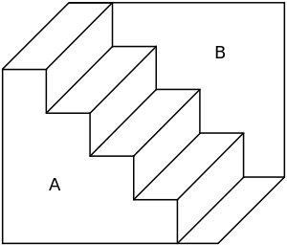

Building Stairs and Railings

You want to build stairs to a second story that is 10 ft high. You decide you want to make them at an angle of 35 degrees. You need to know how long to make the railing. SHOW ALL WORK. Draw a picture.